What is CSS?

- Cascading Style Sheet - A language for styling HTML documents.
  - It lets us define the look and ---position--- of HTML elements.

- CSS uses key/value pairs to indicate which element to style.
  - If this image doesn’t make sense yet we’ll see a ton of examples later
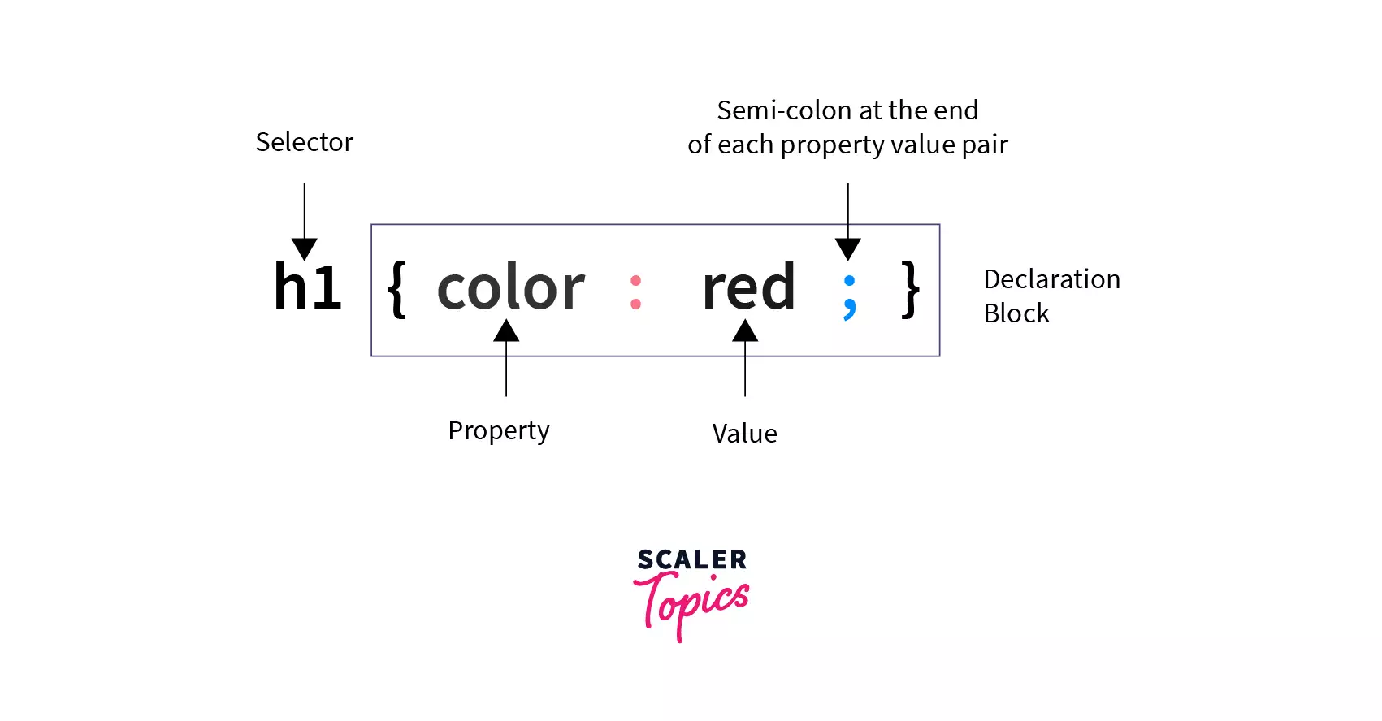

- CSS is broken down into selectors and declarations
  - Selector: Selects the HTML element to style.
  - Declaration: Defines the style you are imposing on the selector.

How can we apply CSS?

- There are three places you can declare CSS styling

- External Style Sheets (this tends to be best practice)
- A separate CSS document that you link to in your HTML head
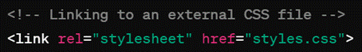
- Internally in the <head> element (uncommon)

- Inline of the actual HTML element tag (not best practice but easy and ok to do in a pinch)

- In case of conflicts? What if you’re trying to style the same element in multiple declarations?
  - The CSS closest to the element will “win” any conflicts. So inline styling beats head styling which beats external style sheets.

CSS Selectors

Selectors are how we choose which HTML element to style (hence SELECTors).

- Element Selectors: Selects all the instances of an HTML element

p {
text-align:center;
color:blue;
}

● ID Selectors: Selects elements by the ID attribute. IDs should be unique. Uses the # to select. Better for individual elements

#div1 {
text-align:center;
color:blue;
}

● Class Selectors: Will style any element with the declared class attribute. Uses the . to select. Can be combined with an element selector! Better for groups of elements.

.intro {
text-align:center;
color:blue;
}

- Sibling Selectors: Selects an element directly after a certain element. Uses the +.

div + p {
text-align:center;
color:red;
}

You can probably just know the above 4 selectors (understand their syntax and how they work.) The rest of them below are nice to know if you want more advanced or slick styling.

● Universal selector - selects everything. Uses the *
* {
text-align:center;
color:pink;
}

● Attribute Selector - Allows you to select elements that declare a specific attribute. Uses the [] to select.
[title] {
text-align:left;
color:blue;
}

[class=”warning”]{
color:green;
}

● Grouping Selectors: you can group multiple selectors and apply the same style. Simply declare the selectors and separate them with a comma
h1, #para1 {
text-align:left;
color:red;
}

● Child selectors - Selects specific elements that are direct children of another specific type of element. Uses the > sign.
div>p {
text-align:left;
color:red;
}

● Conflicts? If selectors conflict with each other, then the “winning” CSS is determined by specificity
○ ID wins over everything
○ Class beats anything under ID
○ Element is the lowest priority
○ If specificity does not resolve the conflict, the determination is made by the order of the declarations. The latest declaration declared will win.

CSS Box Model

● CSS treats each HTML element in the document as a “box”. Each box has its own 4 regions that can all be styled independently of one another. These regions are typically used to position an element on the page
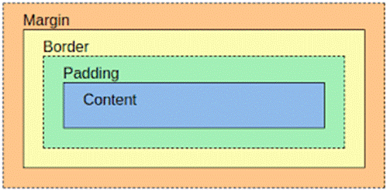

Margin: The outermost layer. Useful for separating the element from its neighbors. The dimensions are given by the margin-box height/width.

Border: The layer between the margin and padding, its dimensions are given by the width and height of the border. The default border style is no border – you can edit this attribute to get a |visible border|.

Padding: The layer between the content and within the border box. Its dimensions are given by the width and height of the padding box. Useful for making space between the border and content.

Content: This consists of the actual content of the element such as text, images, or any other media. Its dimensions are given by width and height, but we don’t usually edit these heavily.

Other Commonly Styled CSS Properties

There are many, many properties that can be styled with CSS. Some include:

- Color: Allows you to change the color of an element
  - Includes simple options like “red” but you can use rgb or hex color codes
  - Color is everywhere – most elements can be given a color.

- Position: Determines where on the page an element is displayed
  - Static - The element’s box is arranged normally. This is the default.
  - Relative - Defaults to the normal position, but can change RELATIVE to the other elements’ positioning
  - Absolute - The element’s box is placed in an ABSOLUTE position on the page, such as top right or bottom left. When you scroll, it will follow.
  - Fixed - The element’s box is in a FIXED location in the window, unaffected by user scrolling or other elements.

- Text Align: Sets the text inside the content to be of a particular alignment. I.e. left/right justified, or centered

- Font: Chooses the font of text-based elements, with options such as:
  - Font-family
  - Font-size
  - Font-weight (for bolding)
  - Font-style (for italics)

- Background: Configures the styling of the background of the page
  - Background-color
  - Background-image
  - Background-size
  - Background-position

*Ben showed Bootstrap, which is one of many styling frameworks that let you steal premade CSS to make styling quick and easy

All you have to do is grab this link:

<link href="https://cdn.jsdelivr.net/npm/bootstrap@5.3.8/dist/css/bootstrap.min.css" rel="stylesheet" integrity="sha384-sRIl4kxILFvY47J16cr9ZwB07vP4J8+LH7qKQnuqkuIAvNWLzeN8tE5YBujZqJLB" crossorigin="anonymous">

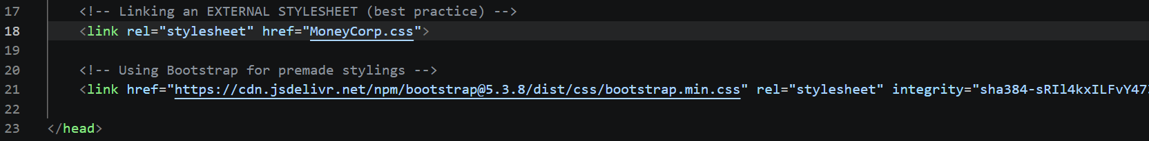
See the HelloHTMLCSS demo for all your styling needs

Get good at CSS and you can make beautiful webpages like this

